**8.1**

SELECT list_price,

FORMAT(list_price, 1) AS formated_price,

CONVERT(list_price, SIGNED) AS converted_price,

CAST(list_price AS SIGNED) AS casted_price

FROM products;

**8.2**

SELECT date_added,

CAST(date_added AS date) AS casted_date,

CAST(date_added AS CHAR(7)) AS year_and_month,

CAST(date_added AS time) AS time_only

FROM products;

**9.1**

SELECT order_date,

DATE_FORMAT(order_date, '%Y') AS four_digit_year,

DATE_FORMAT(order_date, '%b-%d-%Y') AS abr_months,

DATE_FORMAT(order_date, '%h:%i %p') AS hour_min,

DATE_FORMAT(order_date, '%m/%d/%y %H:%I') AS full_date

FROM orders;

**9.2**

SELECT email_address,

REGEXP_REPLACE(

REGEXP_SUBSTR(email_address, '^[A-Z]*@'), '@', '') AS user_name,

REGEXP_REPLACE(

REGEXP_SUBSTR(email_address, '@([A-Z]|\.)*'), '@', '') AS domain_name

FROM administrators

**10.1**

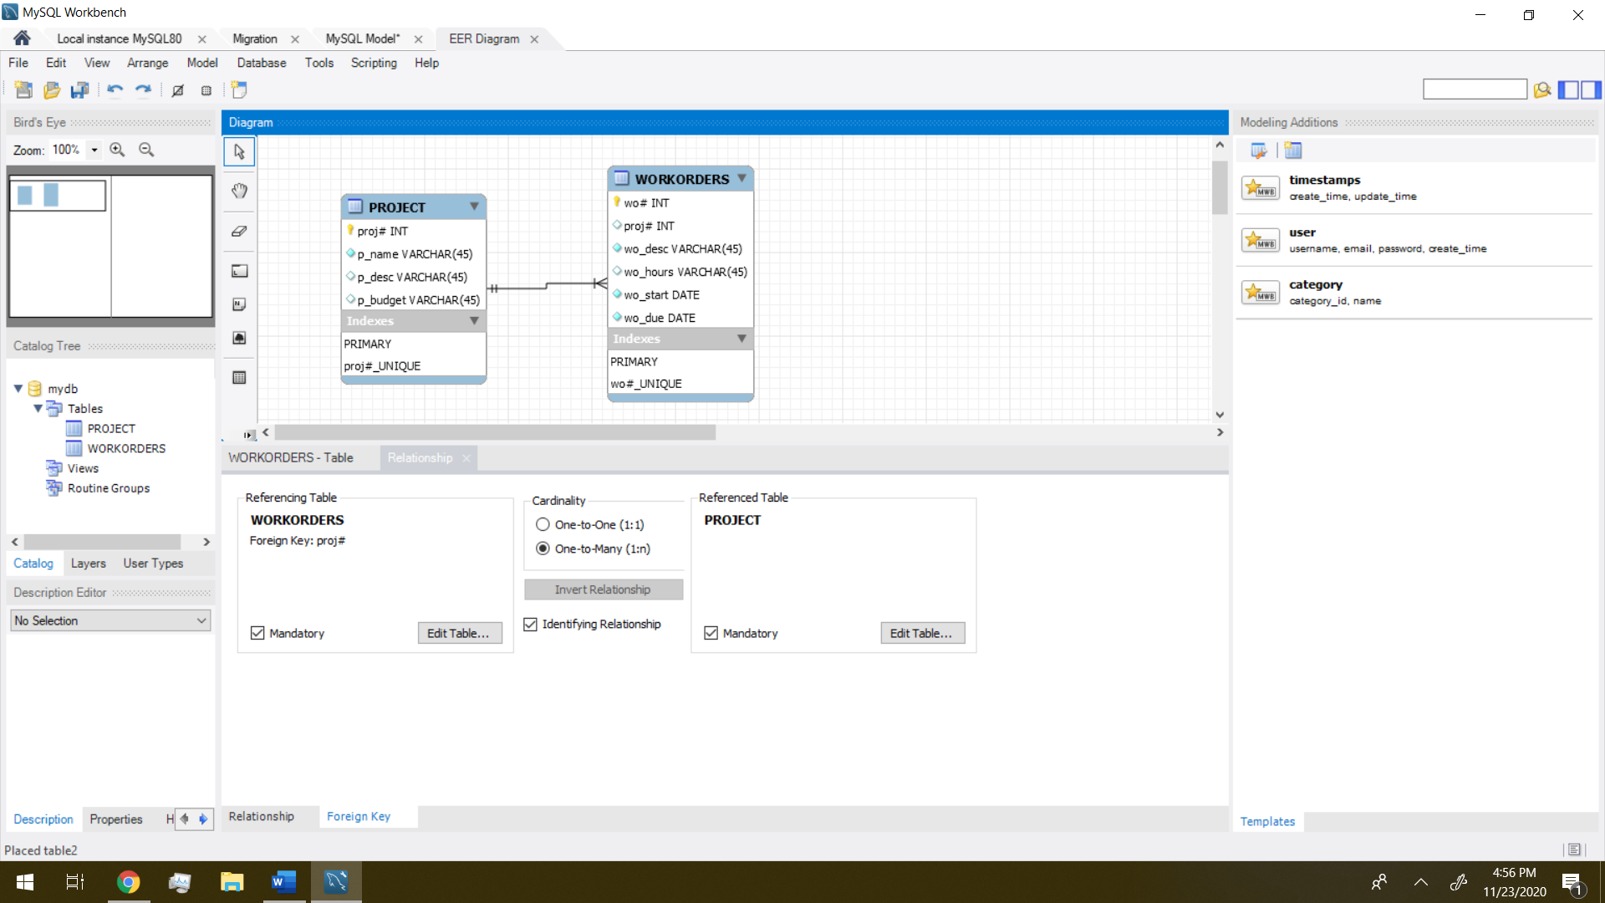

**11.1**

CREATE INDEX addresses_zip_code_index

ON addresses (zip_code)

**11.2**

CREATE DATABASE IF NOT EXISTS my_web_db;

USE my_web_db;

CREATE TABLE users

(

user_id INT PRIMARY KEY UNIQUE,

email_address VARCHAR(100),

first_name VARCHAR(45),

last_name VARCHAR(45)

);

CREATE TABLE products

(

product_id INT PRIMARY KEY UNIQUE,

product_name VARCHAR(45)

);

CREATE TABLE downloads

(

download_id INT PRIMARY KEY UNIQUE,

user_id INT,

download_date DATETIME,

filename VARCHAR(50),

product_id INT,

CONSTRAINT downloads_fk_users

FOREIGN KEY (user_id)

REFERENCES users (user_id),

CONSTRAINT downloads_fk_products

FOREIGN KEY (product_id)

REFERENCES products (product_id)

);

**11.3**

USE my_web_db;

INSERT INTO users

(user_id, email_address, first_name, last_name)

VALUES (1,"johnsmith@gmail.com","John","Smith");

INSERT INTO users

(user_id, email_address, first_name, last_name)

VALUES (2,"janedoe@yahoo.com","Jane","Doe");

INSERT INTO products

(product_id, product_name)

VALUES (1,"Local Music Vol 1");

INSERT INTO products

(product_id, product_name)

VALUES (2,"Local Music Vol 2");

INSERT INTO downloads

(download_id, user_id, download_date, filename, product_id)

VALUES (1,1,NOW(),"pedals_are_falling.mp3",2);

INSERT INTO downloads

(download_id, user_id, download_date, filename, product_id)

VALUES (2,2,NOW(),"turn_signal.mp3",1);

INSERT INTO downloads

(download_id, user_id, download_date, filename, product_id)

VALUES (3,2,NOW(),"pedals_are_falling.mp3",2);

SELECT email_address, first_name, last_name, download_date, filename, product_name

FROM users

JOIN downloads

ON users.user_id = downloads.user_id

JOIN products

ON products.product_id = downloads.product_id

ORDER BY email_address DESC, product_name ASC;

**11.4**

ALTER TABLE products

ADD COLUMN product_price DECIMAL(5,2) DEFAULT 9.99,

ADD COLUMN add_date DATE;

**11.5**

ALTER TABLE users

MODIFY first_name VARCHAR(20) NOT NULL;

UPDATE users

SET first_name = null

WHERE user_id = 1;

UPDATE users

SET first_name = "123456789012345678901"

WHERE user_id = 1;

**12.1**

USE my_guitar_shop;

CREATE OR REPLACE VIEW order_item_products AS

SELECT o.order_id, order_date, tax_amount, ship_date, product_name, item_price,

discount_amount, item_price - discount_amount AS final_price, quantity, (item_price - discount_amount) * quantity AS item_total

FROM orders AS o

JOIN order_items AS oi

ON o.order_id = oi.order_id

JOIN products AS p

ON oi.product_id = p.product_id;

**12.2**

CREATE OR REPLACE VIEW product_summary AS

SELECT product_name, COUNT(order_id) AS order_count, SUM(quantity) AS order_quantity_total, SUM(item_total) AS order_total

FROM order_item_products

GROUP BY product_name;

**12.3**

SELECT product_name, order_total

FROM product_summary

ORDER BY order_total DESC

LIMIT 5